

Pupil Supervision and

Lost & Missing Children Policy



September 2025

Introduction
1.1 Brighton College takes seriously its responsibility to ensure that pupils are always supervised properly to ensure their safety while on school premises or on out of school visits. Staff who supervise are mindful of our Safeguarding and Child Protection Policy, Anti Bullying Policy, and our health and safety requirements. This policy applies to all year groups.

1.2 This policy applies to all children, including those in the early years.

Working Day

The school day is as follows:
Age range | Timings
2-10 | 08:30 – 15:30
11-13 | 08:30 – 16:00

Start of Day Arrangements

When pupils arrive at school, they are expected to be greeted by a member of staff when entering the building. They then move to their classroom or form room, where they will be registered by their form tutor or class teacher.

3.2 Before school, no supervision arrangements are in place.

3.3 For pupils arriving by bus, they are expected to be greeted by a member of staff when entering the building.
`

Break Time Arrangements

During break, the following arrangements are in place:
Year 1-8 pupils are supervised in the outside garden with 3 members of staff on duty (2x in garden & 1 x on the gate)

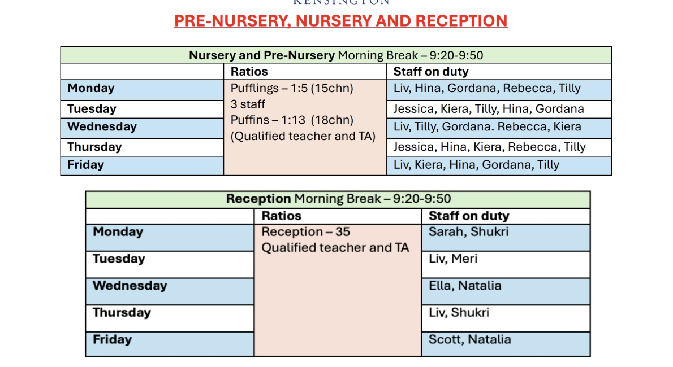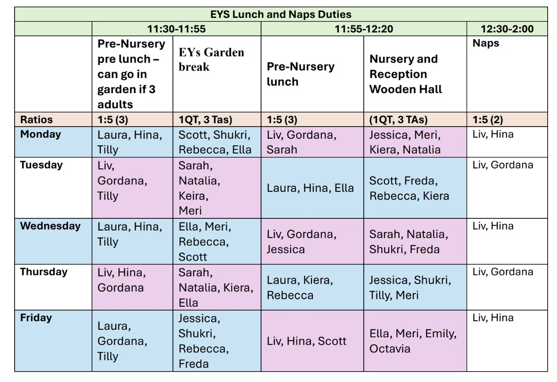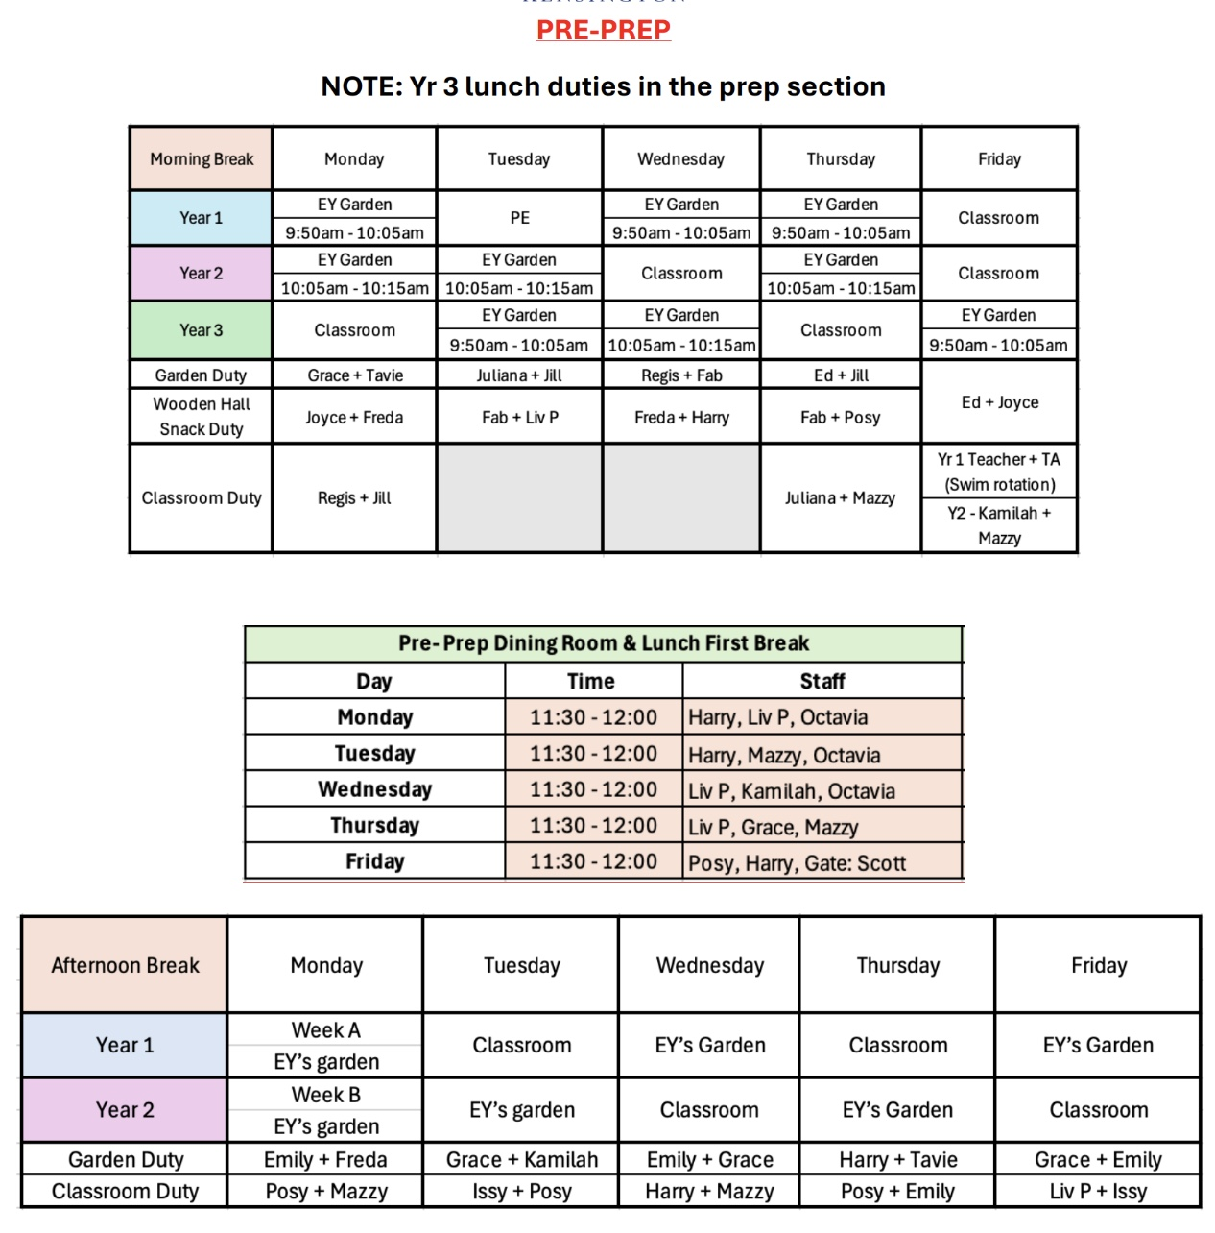

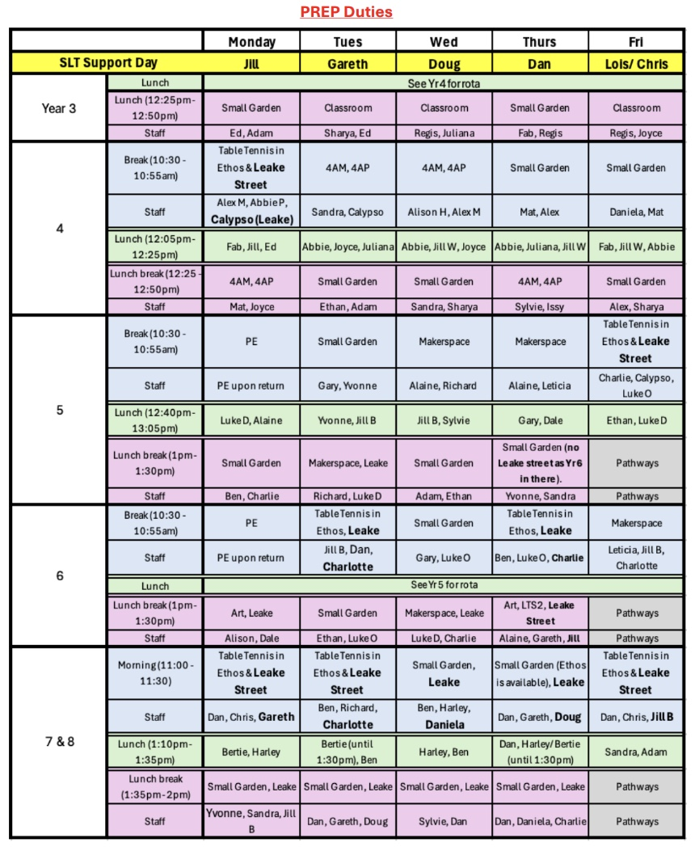

During break, the following supervision arrangements are in place for Wet Play: Pupils go to specific locations which are supervised by rota staff.

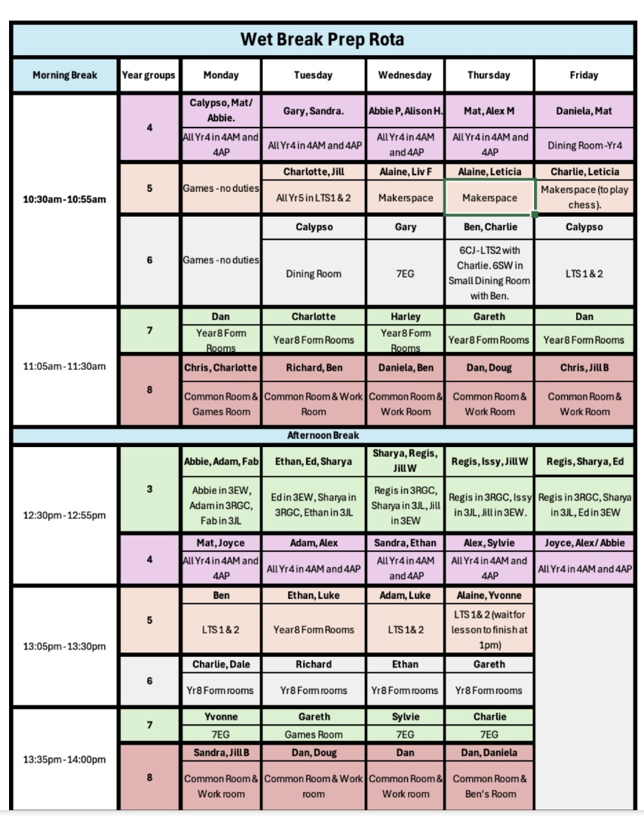

Lunch Time Arrangements

During lunch, the following arrangements are in place Year 1-8 pupils are supervised in the outside garden with 3 members of staff on duty (2x in garden & 1 x on the gate)
SEE ABOVE DUTIES

During lunch break, the following supervision arrangements are in place for Wet Play: Pupils go to specific locations which are supervised by rota staff.

SEE ABOVE DUTIES

End of School Day Arrangements

Pupils are expected to leave the premises by 15:3016:00/17:00 unless they are attending an after-school activity. No pupils may be in any other area of the school site unless under the direct supervision of an authorised adult. Pupils will leave the school under supervision of the member of staff responsible and handover happens to parent/carers according to pickup arrangements. If a pupil is leaving on their own, permission must have been granted by the parent and communicated with the school.

For pupils travelling by bus, a member of staff signs the pupils onto the correct bus.

Schools will support any court orders in place, in relation to collection of children and contact arrangements. Should a parent who is due to collect their child according to the order not arrive, then the school will telephone them initially. If schools fail to make contact within 30 minutes, the school will call the other parent and request they collect their child. Should a parent, who is not due to collect their child arrive at the school with the aim of collection, then the parents will be advised to make agreed arrangements. This communication will take place off site (see Safeguarding Policy)

Non-Collection Arrangements at End of Formal School Day

If a pupil is not collected from school they should wait in reception until a member of staff contacts parents.

After School Activities

When attending an after-school activity, pupils are supervised by authorised adults The adult facilitating the after-school activity is responsible for taking a register at the activity.

8.2 No pupil should leave without the authorisation of the adult leading the activity subject to suitable and agreed handover arrangements.

The following procedure will be followed when a pupil is not collected by their parents/carers at the end of the After School Activity: they should wait in reception until a member of staff contacts parents.

Sporting Fixtures

PE staff supervise students when at fixtures-a minimum of 2 staff members in case of emergencies, illnesses, or other events where one staff member has to supervise, and another has to look after an individual child.

Parents are always informed of the finish times and where they must collect their children.

9.3 No pupil should leave the sporting fixture and the supervision of the staff member without their authorisation and their handover to their parent supervised.

No staff member must leave the sporting fixture without checking that all children have been safely collected; routine checks of changing areas must be conducted.

9.4 The following procedure will be followed when a pupil is not collected: The member of staff on reception will contact the parents of the child who has not been collected. .

Travel to and from School on Buses

Parents are responsible for ensuring that their children travel safely to and from school. Pupils are not supervised by school staff when travelling on buses and they are expected to behave responsibly and to follow the driver’s instructions. This includes wearing a seat belt at all times.

10.2 The Headteacher reserves the right to prohibit a specific pupil from travelling on school sponsored transport if their behaviour does not meet the required standard.

10.3 Please see above section 3.3. for arrival information and 6.2 for departure information.

Leaving the Site during the School Day
11.1 It is expected that all pupils will be on site for the entire day unless they have specific permission to leave.

Supervision Duties
12.1 All members of the staff are expected to take their share of break and lunchtime supervisory duties. For more information on staff duties, please see the duty rota.

12.2 All classes will be supervised by the relevant teacher and in certain subjects, for example food, art and science; the teacher may be supported by a technician.

Supervision during PE Lessons, including Changing Arrangements
13.1 PE lessons are supervised by members of the teaching staff. When older pupils are changing or showering, teachers must be mindful of both their responsibility for appropriate supervision and the need for a pupil’s privacy, with due regard for the Safeguarding and Child Protection Policy. Staff will only enter the changing facilities where they believe not to do so may place a child at risk. Younger children e.g., those under aged 7 years, and those with SEND may require full supervision or support with changing, undertaken by two teachers being present.

Medical Support
14.1 There is a qualified paediatric first trained member of staff every day. They are available to administer first aid, to help if someone is ill or injured, and to deal with any accidents or emergencies. A pupil who feels unwell during the day should report to reception

Supervision in Remote Locations
15.1 Some potentially dangerous areas of the school are out of bounds to unsupervised pupils. These include science laboratories and the grounds, maintenance, catering and caretaking areas of the school and the garden.

Lost or Missing Children

In the instance that a child is lost or missing whilst on the school site we will follow the following procedure:

In the instance that a child is thought to be lost or missing on whilst off-site we will follow the following procedure:

Version control:

Ownership and consultation
Document Sponsor | Group Director of Education
Document Author / Reviewer | Regional Safeguarding Lead (RSL)  Reviewed by RSL June 2024
Consultation & Specialist Advice
Document application and publication
England | Yes
Wales | Yes
Spain | Yes
Switzerland
Italy
Version control
Current Review Date | September 2025
Next Review Date | September 2026
Related documentation
Related documentation | Independent School Standards  British Schools Overseas Standards

