



Behaviour Policy

Introduction

This policy is designed to foster a school ethos that promotes high quality teaching and learning to support the wellbeing of our pupils in order for them to thrive in an environment of respect and collaboration. The implementation of this policy supports the fair and transparent treatment of all pupils. The School aims to encourage pupils to adopt the highest standards of behaviour, principles and moral standards and to respect the ethos of the School.

This policy applies to all pupils including those in the Early Years parents/carers, and staff.

We are committed to promoting and protecting the safety and well-being of all our pupils and staff and take great pride in the behaviour and conduct of all our pupils. We provide a safe and affirming place for children where they can develop a sense of belonging and feel able to trust and talk openly with adults about their problems.

In keeping with Education (Independent School Standards) (England) Regulations 2014/British School Overseas Standards (as amended), our policy outlines our Code of Conduct for pupils, as well as the use of sanctions and rewards to ensure our high standards are maintained. We have a duty to ensure arrangements are made to safeguard and promote the safety welfare of children.

The Headteacher is responsible for developing this policy within the framework set by Cognita as proprietor. This means that the Headteacher decides and sets the standard of behaviour expected of all pupils in our school. This includes how the standards will be achieved, the school rules, any sanctions for breaking the rules, and rewards for good behaviour. The measures in our policy aim to promote good behaviour, self-discipline and respect, and ensure that pupils complete assigned work and regulate conduct. Teachers have the power to discipline pupils for misbehaviour which occurs in school and, in some circumstances, outside of school (including online).

This policy should be read in conjunction with the School’s other applicable policies including our Anti-Bullying Policy, Safeguarding and Child Protection Policy, Suspension, Expulsion and Removal in Other Circumstances Policy, Drug and Alcohol Policy, SEND Policy, , Staff Code of Conduct, IT Policy, Use of Reasonable Force, Restrictive Interventions and/or Restraint Policy (incorporating Searching, Screening and Confiscation) Policy, and Child Absent from Education, Child Missing Education and Attendance Policy].

The School takes its duties under the Equality Act 2010 seriously and makes appropriate reasonable adjustments for pupils with special educational needs and disabilities (SEND) or certain health conditions. We are mindful that not all pupils requiring support with behaviour will have identified SEND.

If any pupil’s behaviour is considered by the Headteacher to be criminal or to pose a serious threat to a member of the public, then it will always be reported to the relevant Police authority. If any misbehaviour is considered to be linked to any child experiencing, or being likely to experience, significant harm, then our Safeguarding and Child Protection Policy will be rigorously followed, and action will be taken in accordance with the relevant local Safeguarding Partners referral procedures. If any child is in immediate danger or is at risk of harm, a referral will be made to children’s Social Care and/or the Police immediately in accordance with the provisions of the Safeguarding and Child Protection Policy.

We publish our policy for parents/carers, pupils and staff. It can be found on our website. We review this policy at least annually, and when significant changes are required under government guidance. This policy is referred to in our Parent Contract accordingly.

We support pupils at times when difficult events happen in their lives, such as domestic abuse, bullying, accidents, transition, loss of friendships, divorce and separation, loss and bereavement. This helps pupils to build coping strategies and build resilience, which helps to prevent mental health problems from occurring later in life.

Our approach

Good behaviour is essential for effective learning to take place. Our school policy presents a fair, consistent and transparent approach towards behaviour management, which combines appropriate discipline with support and encouragement delivered within our caring school environment.

We work in partnership with our parents/carers, pupils and staff to create an atmosphere of mutual respect and understanding. Our written policy reflects this approach in that we balance discipline and sanctions with a strong commitment to encouraging and supporting positive behaviour. We expect our staff, parents/carers and pupils to understand and respect the rules of the school and the expectations and responsibilities outlined in this policy. We expect both staff and parents/carers to model positive behaviours at all times so that our pupils can benefit fully from their experiences in school.

It is important that our staff follow this policy at all times to ensure that it is implemented consistently and effectively. We understand that this will ensure that our pupils feel they have been treated fairly compared to others.

Should any child display severe emotional, behavioural and social difficulties, it is our role to support them to be resilient and mentally healthy, and to ensure that all children are properly included in the educational experiences and opportunities provided whilst the learning of their peers is not impeded.

Where needs emerge, we will ensure that this is communicated to the child’s parents/carers from the outset, and that the child receives early help via external support such as via early help services, from medical professionals working in specialist Child and Adolescent Mental Health Services (CAMHS), voluntary organisations and local GPs. This is in conjunction with internal targeted support in school.

Staff work closely with the Special Educational Needs Coordinator (SENCo) and Designated Safeguarding Lead (DSL) to ensure we have a good understanding of the mental health support services available in our locality, both through the NHS and voluntary/private organisations/professionals.

School Principles

Good schools encourage good behaviour through a mixture of high expectations, clear policy and an ethos which fosters discipline and mutual respect between pupils, and between staff and pupils.

The quality of learning, teaching and behaviour are inseparable issues and are the responsibility of all staff.

The School Principles:

- School staff and pupils should all show respect for one another;
- Good behaviour should be the expectation, and, in parallel with support for all those involved, sanctions should always be applied consistently for unacceptable behaviour, including all forms of child-on-child abuse, including but not limited to bullying, inappropriate/harmful sexual behaviour, and violence ( see the Safeguarding and Child Protection Policy for further information);
- Appropriate and preventative action should be taken to reduce the risk of poor behaviour occurring, including particular action to prevent a disproportionate number of behaviour issues arising amongst more vulnerable groups of pupils, for example, but not limited to those with special educational needs or disabilities;
- Pupils whose behaviour and attendance may deteriorate through events such as bereavement, abuse/neglect/exploitation, or through the divorce or separation of parents should be identified and those children supported;
- All pupils should be listened and responded to;
- All pupils are entitled to learn in a safe and secure environment;
- Pupils should act as appropriate ambassadors for the school on, for example, School trips, work placements, sports events and journeys to and from the School;
- All School staff should model positive behaviour and promote it through active development of pupils' social, emotional and behavioural skills; and
- All members of the School community should understand and accept the principles on which this policy is grounded.

Expectations and Responsibilities

Behaviour is the way we act and respond to people and to situations in which we find ourselves. Our aim is that all of our pupils should be able to behave in socially acceptable ways.

Teachers have authority in our school to discipline pupils for misbehaviour which occurs in school and this power applies to all paid staff with responsibility for pupils on/off site; unless the Headteacher says otherwise.

To be socially acceptable, we believe that our pupils should be able to:
- Treat other pupils and staff with respect and kindness;
- Speak politely to other people; and
- Have self-confidence and high self-esteem.

To encourage this, the staff will:
- Treat all pupils and adults with respect and kindness;
- Speak politely to other people;
- Praise all pupil’s efforts and achievements as often as they can;
- Explain to pupil’s what they should have done or said when they get it wrong;
- Encourage self-reflection to pupil’s when they get something wrong to encourage learning;
- Tell parents/carers in a timely manner about their child’s efforts and achievements, any concerns around behaviours, and explain any concerns about risk to self/others arising from the behaviour; and
- Avoid using critical, belittling or sarcastic language towards all pupils and adults.

We will not accept the following behaviour from pupils or adults (including staff):
- Use of unkind or rude language;
- Hitting, kicking, biting or other such physical responses; or
- Racist, sexist or homo/bi/transphobic remarks, or other discriminatory comments towards anyone including those with protected characteristics (Equality Act 2010).

The role of the teacher
- Teachers are responsible for ensuring that the School’s behaviour policy is enforced in their class, and that their classes behave in a responsible manner during lesson time;
- Incidents of poor behaviour may (where appropriate) be discussed by the teacher with the class, e.g. during circle or pastoral time;
- Every teacher enforces the classroom code consistently and treats each pupil fairly and equally;
- Staff should always make it clear that they are upset about the pupil’s behaviour, not the pupil. They should always use private, not public, reprimands, so that when a sanction is applied the pupil can make a fresh start.
- If a pupil misbehaves in class, the teacher will keep a record using the school behaviour recording system of all such incidents; dealing with the matter themselves in the first instance. However, if the behaviour continues, they must seek help and advice from the senior member of staff named at the front of this document, including a conversation with the parent/carer to seek improvements and the use of appropriate strategies;
- Any behaviour which constitutes a safeguarding concern will be escalated to the Designated Safeguarding Lead (DSL) who take any required action.
- The teacher reports to parents/carers about the progress of each pupil for whom they are responsible, in line with our School policy. The teacher/DSL may also contact a parent/carer if there are concerns about the behaviour or welfare of any pupil, with reference to the School’s Safeguarding and Child Protection Policy as appropriate;
- A record is made of any incident involving a pupil, or staff member which results in personal injury or damage to property. These include loss or theft, deliberate damage and any other serious incident. These are reported to the Headteacher and parents/carers. We record all details fully and accurately. Incidents are recorded in online logs and are kept in school and records maintained in the child’s personal file.
- Obey all health and safety regulations in classrooms, around the School and in all off site educational activities including helping to keep the School clear of clutter and litter;
- Never make racist, sexist, homo/bi/trans phobic or other abusive or humiliating remarks, including to those with protected characteristics (Equality Act 2010);
- Never resort to physical interventions to manage behaviours (other than in situations where there is risk of harm/danger)
- The use of reasonable force and restrictive interventions, including the use of seclusion, may be used exceptionally and only to prevent injury to pupils, staff, damage to property or to prevent pupils committing an offence. Only the minimum restraint is used for the briefest length of time. The action taken is recorded by the person who undertook the intervention,the parents/carer must be informed the same day and provided with the school record of the intervention as soon as practical. Please see our separate policy on the Use of Reasonable Force, Restrictive intervention and/or Restraint (incorporating searching, screening and confiscation) for further details;
- Comply fully with the Safeguarding and Child Protection Policy, Staff Code of Conduct, and the IT Policy

Expectations of pupils in our school

The school expects high standards of behaviour. Pupils are encouraged to maintain a good work ethic and good levels of behaviour. Each member of staff is expected to promote self-discipline amongst pupils and to deal appropriately with any unacceptable behaviour.
It is understood that there will be variations in staff acceptance and tolerance of behaviour in class depending on the nature of the class and content of the lesson., but behaviour which does not allow constructive teaching and learning is totally unacceptable and all staff have a duty to ensure that such behaviour is not tolerated
Everyone at Brighton College Prep has the right to feel secure and to be treated with respect. Bullying will not be tolerated, and the school’s anti bullying policy is available on the website.

SCHOOL RULES
Our aim is to reward and encourage good behaviour, while sanctions help us to set boundaries to manage challenging behaviour. In this way, our intention is to help pupils understand what is expected of them and why sanctions may be imposed for inconsiderate and unacceptable behaviour. Pupils are encouraged to use common sense and behave in a way that reflects the best interest of the whole community and which supports our school ethos that kindness is the currency.
Parents and Guardians undertake, when signing the Parent Contract, to support the authority of the Head in enforcing our rules in a fair manner that is designed to safeguard the welfare of the community as a whole.
The Head, for her part, undertakes to ensure that sanctions are applied fairly throughout the school and where appropriate, after due investigation has taken place.
The Deputy Head oversees the discipline policy at Brighton College Prep Kensington in consultation with the Head, other members of SLT, Tutors and other members of staff.

READY TO LEARN POLICY
Created by our own pupils through the SCHOOL COUNCIL, we have a ready to learn policy that is part of respectful conduct both in class and around school.
Rules around starting the learning process:
Pupils show they are ready to learn by:
- Starting promptly
- Being prepared by having the right resources
- Working to the best of their ability
- Listening respectfully when teachers are talking
- Speaking to others with respect
- Allowing others to learn (do not distract others)
- Keeping off task conversations for social times
- Respecting other pupils’ personal learning space

Fountain pen or roller ball pen – blue/black ink
Pencils
Black fine liner
Transparent ruler
Eraser
Scissors
Highlighter pens
Protractor – either 360 or 180
Glue stick
Erasable green pen
Coloured pencils / felt tip pen
Pair or compasses
Red, green and black biros
Pencil sharpener

DEMERITS, REFLECTIONS & DETENTIONS
If a pupil breaks the code of conduct, they may find themselves in either a HOY Reflection, a Deputy Head’s detention or a Head’s after school Detention.
If a pupil breaks the code of conduct, they will initially find themselves being disciplined by subject teachers or any other member of staff. In the Prep School we have a DEMERIT system. A DEMERIT may be issued for a minor offence and will be issued alongside a teacher-led sanction. Pupils will be reminded that you may not be getting things quite right or not responding to the reasonable requests of school staff. Each demerit will be issues alongside a discussion between the pupil and their form tutor so they can be given appropriate support and guidance.

Parents will also be notified by the teacher if the pupils are given a Head of Year Reflection, so parents are able to discuss any issues with their child.
If a pupil receives three Reflections in one half term, they will receive a Deputy Head’s detention. This will be held at a time of the Senior Deputy Head’s discretion.
This will go on the pupils’ school record and parents will be contacted. A Head’s ‘after school detention’ can also be given for more serious offences or repeated minor offences.

- Comply with the School’s Behaviour Policy at all times
- Arrive on time to lessons/classes with all the equipment needed for the lesson;
- Listen respectfully when a staff member is giving instructions;
- Follow instructions promptly and accurately;
- Follow thestaff member’s instructions about moving around the classroom;
- Treat others with respect, kindness and consideration at all times;
- Dress cleanly and neatly in the specified uniform for the activity;
- Obey all health and safety regulations in classrooms and around the school including helping to keep the school clear of clutter and litter;
- Move sensibly and calmly around the buildings and grounds;
- Never make racist, homo/bi/trans phobic or other abusive or humiliating remarks, including to those with protected characteristics (Equality Act 2010); sexist or other abusive or humiliating remarks;
- Never resort to physical violence; and
- Comply fully with the Digital Safety Agreements.

The above list is not exhaustive.

Mobile Phones
The school follows the DfE guidance (January 2026) which states that ‘all schools should
be mobile-phone free environments by default; anything other than this should be by
exception only.’

Mobile phone usage is prohibited during the school day for pupils up to and including Year
8 includes during lessons, between lessons, at breaktimes and lunchtimes and in clubs before, during
and after school, as well as school visits and trips that take place during typical school
hours. Exceptions to this may be made, but this must be agreed between the school and
parents prior to the device being used in school and will only be approved for exceptional c
ases. The school recognises its duties under the Equality Act 2010 and will consider reasonable adjustments where a pupil requires a device for medical monitoring or other agreed support related to a disability, health condition or learning need. Any exceptions must be documented within the pupil’s healthcare plan or learning support plan. Devices permitted under such arrangements must only be used for the agreed purpose, and where access to a personal device can be supervised and/or provided by school staff through the school day. Smart watches and other wearable devices capable of communication, internet access, photography or recording are treated in the same way as mobile phones. Pupils must not use or wear these devices during the school hours.
Staff must never use their personal mobile phones when pupils are present, may not wear
smart watches and must only use work devices (see Code of Conduct and ITPolicy) mobile phone usage is necessary for work purposes or medical reasons, staff usage must be kept to a minimum.

The school does not condone the ownership of smart phones for pupils. If mobile phone ownership is deemed necessary for pupils by their parents/carers, it is preferable that this should be a basic phone/brick phone/flip phone and not a smart phone. Parents/carers should make informed decisions about the age at which their child should obtain a smart phone and follow up to date government guidance, which at the time of writing is not recommended below the age of 14.

Pupils are encouraged to leave mobile phones at home and not bring them into school. However, it is understandable that many parents/carers may prefer for their child to be contactable traveling to and from school. Therefore, any pupils who has a phone must, hand phones into reception on arrival at school, pupils will hand their phones to the reception team on arrival in school.
They will be stored safely and pupils may ask a member of staff to collect their phone when exiting the building.

The school will direct the use of pupil mobile phones on residential trips and trips outside of the normal hours of the school day. This will be communicated to parents/carers as part of the trip’s communication.

Confiscation
The school reserves the right for all staff to confiscate pupil’s mobile phones should this policy be breached, for example where a mobile phone is used by a pupil or is heard ringing in a pupil’s bag. The law protects staff from liability in any proceedings brought against them for any loss or damage to items they have confiscated as a sanction, providing they have acted lawfully.

In considering whether a confiscation is a proportionate penalty, the schools will consider what disciplinary outcome the confiscation is intended to achieve and whether there are other ways to achieve the same outcome, as well as the pupil’s individual circumstances such as age and SEND status.

The Headteacher is supported by DfE to confiscate mobile phones and similar devices, if they consider it proportionate, for whatever length of time they deem proportionate.

The school will consider whether misbehaviour regarding the use of mobile phones gives cause to suspect that a pupil is already experiencing, or may be at risk of abuse, neglect and/or exploitation. Where this may be the case, as set out in part 1 of keeping children safe in education, school staff will follow the school’s Safeguarding and Child Protection Policy and speak to the Designated Safeguarding Lead (or deputy). They will consider if pastoral support, an early intervention or a referral to children’s Social Care is appropriate. Where necessary, referrals

Expectations of parents

Parents/carers who accept a place for their child at the School undertake to uphold the School’s policies and regulations, including this policy, when they sign the Parent Contract. The School values a close relationship with parents/carers and encourages them to work in partnership with the School to assist in maintaining high standards of behaviour both inside and outside of School. In particular, the School expects parents to support the School’s values in matters such as attendance and punctuality, behaviour and conduct, uniform/dress and appearance, standards of academic work, extra-curricular activities, and homework/private study.

In the event of any behaviour management issue the School will liaise closely with parents where practical and, if relevant, other support agencies.

Policy on rewards and sanctions

Our rewards – promotion of good behaviour

We believe wholeheartedly in positively reinforcing our school values. All children have their individual strengths and passions and should feel valued. Community, integrity and kindness matter and respectful conduct is at the heart of all that we do.

THE PELICAN PATHWAY
“The Pelican Pathway inspires and encourages pupils to reach their full potential, wherever their strengths lie. It celebrates pupils who uphold the qualities we most value in our learning”
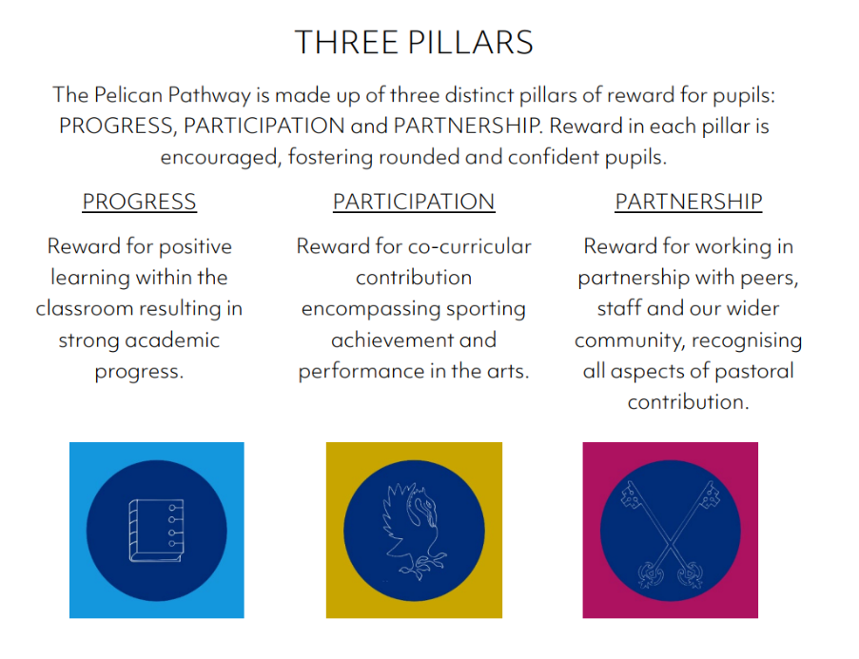

PELICAN POINTS:
To journey along the Pelican Pathway, pupils collect Pelican points which are awarded to them by our staff team. From Reception to Year 2 Pelican points are awarded to pupils when they show clear examples of our defined qualities in any of the three pillars. Their points are recorded in classrooms on their individual 'Pelican Pathway' mats. From Year 3 upwards Pelican points are awarded for upholding the same qualities across each of the three pillars individually. This allows pupils the opportunity to gain separate rewards within each area of school life. Their points are recorded on their own Epraise profile online which is updated live
REWARDS IN THE Nursery and Reception (Early Years)
As the children progress through the school there is a system of positive rewards starting in the Nursery. These are celebrated with the pupils in class and during assemblies with the Head of Pre-Prep or Head of Early Years.
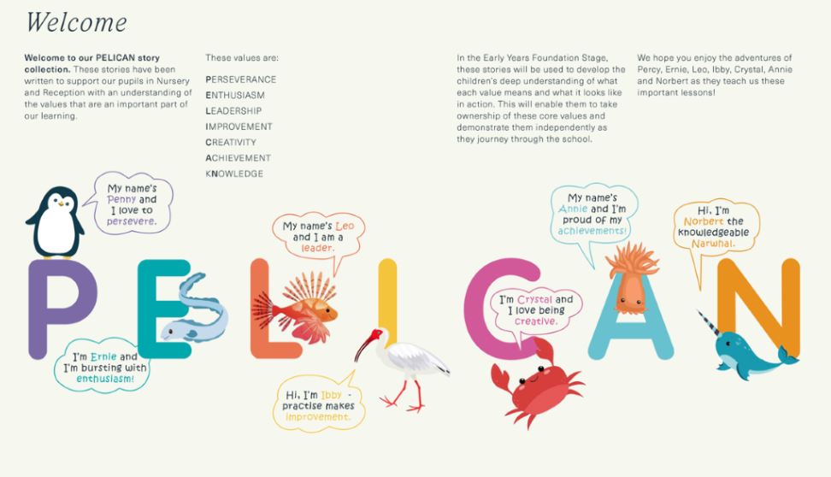
Children are introduced to the Pelican story which helps them to have a solid understanding of our school values which are an important part of our learning and school life. They will receive their own Pelican Pathway Reward Sticker Booklet which helps pupils to visualise their reward journey.
Nursery and Reception pupils are awarded Pelican points when they uphold any of the qualities, we most value in our learning. Reward can be achieved and will be encouraged in each of the seven values which represent the Pelican Pathway. Each week, in Celebration Assembly, children are awarded stickers when they uphold these values. As pupils accumulate their Pelican points, they will be awarded bronze, silver and gold awards. The Pelican Pin and Pelican Crest awards are given to those pupils who achieve significant Pelican point totals over the course of an academic year

REWARDS IN THE PRE-PREP AND PREP SCHOOL:
PROGRESS From Year 1, pupils are awarded Pelican Points in the PROGRESS pillar when they uphold our school values in the academic area of school life. Reward in this pillar can be achieved in all academic subjects, including art, both in lessons and in preps completed at home. Examples include when pupils show creativity with academic problem-solving, high levels of perseverance when faced with a challenging topic, or excellent understanding in a specific academic subject. As they accumulate their Pelican points along the Progress pathway, pupils will be awarded the bronze, silver and gold awards for Progress. The highest reward reached is the Progress Pin or Progress Crest which are awarded to those pupils who achieve significant Pelican point totals over the course of an academic year.

PARTICIPATION Pupils are awarded Pelican Points in the PARTICIPATION pillar when they uphold our school values in the co-curricular area of school life. Reward in this pillar can be achieved in all areas of co-curricular provision, including sport, music and drama. Examples include when pupils show perseverance in their performance technique, leadership skills in games situations or achieve a high level of knowledge in a specific area of music. As they accumulate their Pelican points along the Participation pathway, pupils will be awarded the bronze, silver and gold awards for Participation. The highest reward reached is the Participation Pin or Participation Crest which are awarded to those pupils who achieve significant Pelican point totals over the course of an academic year

PARTNERSHIP Pupils are awarded Pelican Points in the PARTNERSHIP pillar when they uphold our school values in the pastoral area of school life. Reward in this pillar can be achieved in all realms of pastoral development, including personal, community or house initiatives. Examples include when pupils show improvement in their pastoral understanding, effort in developing personal or peer related pastoral qualities or sharing knowledge related to pastoral themes. As they accumulate their Pelican points along the Participation pathway, pupils will be awarded the bronze, silver and gold awards for Participation. The highest reward reached is the Partnership Pin or Partnership Crest which are awarded to those pupils who achieve significant Pelican point totals over the course of an academic year

HOUSE SYSTEM
Each child is allocated to one of the four houses. This is a vertical grouping system, and we aim to keep a balance of gender in each year group in each house. In the Prep school there are regular house meetings at which rewards and sanctions are discussed. The house system aims to encourage healthy competition, cooperation, teamwork and loyalty.


Non-exhaustive examples:
- All staff praise, reward and sanction consistently;
- Younger children are given stars and stickers for good work. They share their work with other teachers and the Headteacher;
- The Headteacher awards (insert) for outstanding achievement to individual children at (insert when/where);
- Two children from Years X and Y are given commendations for good behaviour towards others and receive (insert what);
- House/team points are awarded for good effort, work, helpfulness etc. The points are collected each week/term (amend) and the team/house with the highest points (state award and when); and
- Achievement assemblies take place to support our positive approach and reinforce good behaviour, thereby celebrating all children’s achievements, raising self-esteem and self-confidence.

Strategies and support

The following outline a range of strategies for use in school to reinforce desirable behaviour:
- changes in classroom organisation, seating, etc;
- using different resources;
- setting small and achievable targets;
- short periods of supervised time for personal reflection;
- positive rewarding systems with no comments for undesirable behaviour;
- use of certificates for positive qualities;
- acclaiming good behaviour when it is seen in class;
- involving parents at an early stage to make an action plan together;
- peer mediation and peer mentoring;
- restorative justice approach;
- school counselling sessions to help pupils with social, mental or emotional health difficulties;
- social skills training;
- referral to CAMHS and/or educational psychology services/professionals; and
- referral for family support and/or therapy to help the pupil and family better understand and manage behaviour.

Our sanctions
All staff generally deals with minor breaches of discipline in a caring, supportive and fair manner. A pupil’s individual needs will always be considered carefully. However, if there are any times when children transgress from the acceptable boundaries in our school, they will be spoken with so that they understand the boundaries and what is expected of them.

Corporal punishment is illegal and is never used or threatened at our School.. Physical methods to manage a pupil’s behaviour at home by parents/carers is a safeguarding issue and will be dealt with under the School’s Safeguarding and child Protection Policy.

Examples of sanctions that are used in the School include:

- Verbal reprimand from a member of staff;
- Letter to parents/carers to advise of the misbehaviour;
- Additional schoolwork or repeating unsatisfactory work until it meets the required standard;
- The setting of written tasks as ‘punishments’, such as writing lines or essays;
- Detention;
- Withdrawal of privileges;
- Confiscation of property that is being used inappropriately or without consideration;
- School based service or imposition of a task, under the supervision of a member of staff;
- Assistance with domestic tasks, such as collecting litter;
- Regular reporting, including academic performance reporting, early morning reporting, scheduled uniform, and other behaviour checks, or being identified for behaviour monitoring; and
- Withdrawal from a lesson, school trip or team event.

All misbehaviour or disciplinary incidents will be dealt with as soon as practicable.

We consider whether the behaviour under review gives cause to suspect that a pupil is experiencing, or is likely to experience, significant harm. Where this may be the case, staff will follow our Safeguarding and Child Protection Policy and refer the conduct to the DSL for advice and support before determining any sanction. We will consider whether continuing disruptive behaviour might be the result of unmet educational, SEND, or other needs such as trauma. At this point, we will consider whether a referral to Early Help or other agency is needed to support the child/family.

Parents/carers will be involved at the earliest stage when needs arise, are persisting or recurring.

It should be noted that, in most cases, the school’s sanctions are used in a hierarchical manner. Where cases of serious misbehaviour are evident, the Headteacher reserves the right to use any sanction, including suspension, expulsion and removal in other circumstances, without first using lower-order strategies.

Any sanction must be reasonable in all the circumstances and account must be taken of relevant factors which may include the pupil’s age, any special educational needs or disability they may have, and any religious requirements affecting them. These include the following:

All rewards and sanctions must be applied fairly and consistently. None of the school’s punishments should be degrading or humiliating.

All sanctions are recorded which provides a valuable record of ongoing misdemeanours, helps to establish any trends or patterns in a child’s behaviour.

EXCLUSION
Only the Head can exclude a pupil. Pupils may be excluded for one or more fixed periods or permanently.

Fixed Periods:
For serious but relatively minor breaches of the school’s behaviour and discipline policies pupils can be excluded for one or more fixed-term periods not exceeding 45 school days in one academic year.

For Example:

- Wilful damage to staff/school pupils’ property
- Stealing
- Using inappropriate language
- Entering private areas of the opposite sex
- Aggressive or violent behaviour
- Bullying
- Drug or alcohol use
- Vandalism
- Persistent misdemeanours
- Not respecting differences arising out of gender pregnancy or maternity, disability, race, religion or belief, cultural background, linguistic background, special educational need, sexual orientation, gender reassignment or academic or sporting ability (Equality Act)

A decision to exclude a pupil permanently will only be taken as a last resort when a wide range of strategies for dealing with disciplinary offences has been employed to no avail, or if an exceptional ‘one-off’ offence has been committed.

For example:
- Serious violence, actual or threatened, against a pupil or member of staff
- Sexual abuse or assault
- Supplying an illegal drug
- Carrying an offensive weapon
- Persistent low-level offences
- Ongoing bullying
- Failure to respond to school support systems
- Continuing a course of behaviour that undermines the smooth running of the school community.
- Alcohol abuse
- Frequent examples of suspendable incidents
- Breach of the terms of the Parent contract.

SANCTIONS FLOW CHART – PREP SCHOOL
Initial Sanctions – A Demerit with a teacher led sanction

Demerit will be added to the Epraise rewards/sanctions system as well as count against their overall house point total. Other sanctions will be run alongside this at the discretion of the teacher and communicated with the tutor and HoY.

In class: A demerit to be given and it will involve an initial sanction with the teacher of the lesson. This is actioned and run by the teacher involved with the misconduct.

Examples of behaviour:
Not following the ‘Ready to learn policy’

Break Time: The pupil is immediately sent to the Gate to sit with the duty member of staff for a ‘time-out.’ Demerit will be recorded on Epraise by the end of the day.

Examples of behaviour:
Out of bounds,
Poor behaviour around school
Wearing incorrect clothing

Around School: Poor behaviour during time when not in break or during class.

Sanctions can be given at any time by any member of staff. A demerit is to be given and it will involve an initial sanction with the member of staff. This is actioned and run by the member of staff involved with the misconduct.

Examples:
Poor behaviour walking around school,
Poor behaviour on school transport
Poor behaviour at meal times.

Please Note: All form tutors will monitor their tutees sanctions on Epraise. All demerits will be reviewed at HoY Meetings and Pastoral Team Meetings.



Escalation – Further Sanctions

Sanctions can be escalated by staff members if the pupils have not responded to the teacher’s initial intervention/sanction in class/around school.

IN CLASS: If there is no improvement then it will result in escalation. Pupils will meet with HoY to reflect on behaviour. Parents/Guardians will be notified if this has occurred. The teacher who escalated the sanction will need to follow up with communication home, by email or telephone call.

This will be recorded on Epraise as a HoY Reflection

AROUND SCHOOL or BREAK TIME: If after the ‘time out’ or initial sanction the pupil repeats behaviour, the member of staff will escalate, and they will be sent to school office. The pupil will meet with the HoY to reflect on their behaviour. Parents/guardians will be notified if this has occurred. The member of staff who escalated the sanction will need to follow up with communication home.

The sanction will be recorded on Epraise as a HoY Reflection.

At any intervention stage the pupils will reflect on their own choices alongside the school values.

Deputy Head’s Detention
Numerous pastoral demerits or more serious one-off incidents of behaviour will result in a Pastoral Detention with the Deputy Head.

Examples:
Repetitive poor behaviour – 3 Reflections in one half of term.
Unkindness
Rudeness to staff
Cheating
Consistently not following the ‘Ready to Learn Policy.

Head’s Detention

One or more serious misdemeanour will result in a Head’s Detention

The Deputy Head will contact parents.

Examples:
Acts of violence, swearing/ rudeness to staff/ out of bounds/ compromising safety of staff and pupils.

Monitoring: SLT

Temporary Exclusion (External or Internal)

Deputy Head or Head will contact parents. Behaviour or Work Contract will be signed upon pupils return

Report Card with weekly meetings with the HoY to be put in place.

Examples: Repeated Head’s detentions or a one-off more serious incident.

UNIFORM EXPECTATIONS
All children are expected to wear the school uniform. Variations from the agreed uniform list are not permitted and children must ensure that the correct footwear, coats and knitwear are worn.
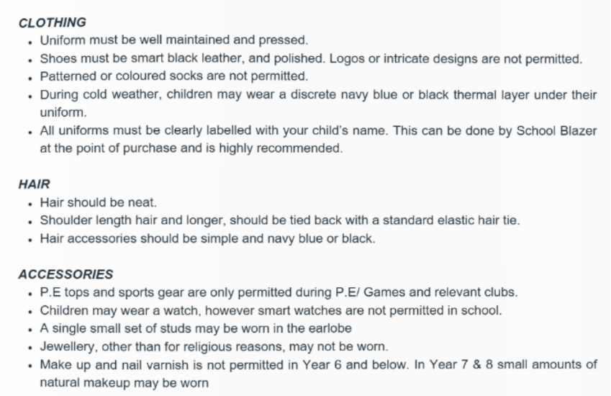

Girls’ School Uniform
Winter Uniform
Navy crested wool blazer
Navy crested cardigan
White long-sleeved blouse
Tartan Skirt
Tartan Trousers (optional)
Navy crested storm-proof coat
Navy crested quilted jacket
Navy waterproof jacket
Navy waterproof trousers
Navy felt hat
Black tights
Long black socks
Black crested bookbag
Black crested rucksack
Black scarf (optional)
Plain black leather shoes (laces or Velcro – not ‘trainer’ style

Girls’ Sports Uniform
Navy crested tracksuit top
Burgundy crested mid-layer
Burgundy and navy reversible games shirt
Navy crested training pants
Navy rugby shorts
Navy running shorts (optional)
Navy skort
Navy crested base layer
Navy crested base layer leggings
Navy and burgundy games socks
Navy crested games bag
Navy swimming costume
Navy crested swim cap
Navy crested swim bag

Boys
Winter Uniform
Navy crested wool blazer
Navy crested jumper
White long-sleeved shirt
Grey trousers
Tie
Navy crested storm-proof coat
Navy crested quilted jacket
Navy waterproof jacket
Navy waterproof trousers
Navy cricket cap
Grey ankle socks
Black crested bookbag
Black crested rucksack
Black scarf (optional)
Plain black leather shoes (laces or Velcro – not ‘trainer’ style

Boys’ Sports Uniform
Navy crested tracksuit top
Burgundy crested mid-layer
Burgundy and navy reversible games shirt
Navy crested training pants
Navy rugby shorts
Navy crested base layer
Navy crested base layer leggings
Navy and burgundy games socks
Navy crested games bag
Navy swim jammers
Navy crested swim cap
Navy crested swim bag

Suspension and Expulsion

The Headteacher reserves the right to suspend, expel or remove pupils from the school. Suspension and expulsion will be dealt with in accordance with our Suspension, Expulsion and Removal in Other Circumstances Policy, which includes examples of behaviour that may warrant those sanctions.

Allegations of Harmful Sexual Behaviour (HSB) and child on child abuse

Allegations of a pupil demonstrating Harmful Sexual Behaviour (HSB) and/or child on child abuse are taken seriously and dealt with in a fair and consistent manner that provides effective protection for the victim and supports the person about whom the allegation has been made, and always in consultation with the Designated Safeguarding Lead. All allegations will be dealt with in accordance with the Safeguarding and Child Protection Policy. The school will, in most cases, engage with both the victim and the alleged perpetrator’s parents/carers when there has been a report of HSB/child on child abuse, unless to do so will heighten risk to the victim/alleged perpetrator. All parties involved will be provided with appropriate support and guidance and schools will carefully consider what information is shared with respective parents/carers to ensure that confidentiality is maintained. Every effort will be made to ensure confidentiality is maintained while an investigation is underway, to the extent appropriate. Referrals to children’s Social Care/Police will be made as appropriate, in line with the Safeguarding and Child Protection Policy.

Complaints Procedure

We hope that any difficulty or concern with this Policy can be sensitively and efficiently handled and resolved informally before it reaches the formal complaints stage. We expect our parents/carers to share any concerns informally with us so that we can continuously improve the quality of education at our school.

The School’s Complaints Procedure [(which apply equally in the EYFS setting)] is on our website and sets out how current parents can raise a formal complaint and how the School will handle it.

Monitoring and Evaluation

The School will record all behavioural incidents (including child on child abuse, including, but not limited to bullying) and sanctions in accordance with this policy which will be used to monitor behavioural issues within the School and to evaluate the effectiveness of this policy. The Headteacher is responsible for ensuring these records are appropriately maintained.

The School will consider whether there are patterns of concerning, problematic or inappropriate behaviour among pupils which may indicate that there are possible cultural issues within the School which may be enabling inappropriate behaviour to occur. When patterns are identified, the School will decide an appropriate course of action, which may include more staff training, incorporating learning points into pupil's PSHE/RSE lessons, or amending this policy.

The Headteacher is responsible for the implementation of this policy and for reviewing from time to time to evaluate its implementation and impact.

Headteachers report on behaviour and bullying at governance meetings. This forms the monitoring and evaluation function of the proprietor.

Where there are concerns regarding the school’s approach to dealing with behaviour, these will be explored by the European Director of Education.

Ownership and consultation
Document Sponsor | Group Director of Education
Document Author / Reviewer | Director of Education, Europe and USA
Consultation | Regional Lead for Inclusion, Europe and USA  Regional lead for Safeguarding, Europe and USA
Document application and publication
England | Yes
Spain | No
Switzerland | No
Italy | No
Greece | No
USA | No
Austria | No
Version control
Current Review Date | March 2026
Next Review Date | September 2026
Related documentation
Related documentation | Anti-Bullying Policy  Exclusion Policy  Safeguarding and Child Protection Policy  Use of Reasonable Force, Restrictive Intervention and/or Restraint Policy  IT Policy  Code of Conduct

